How fork-join works?
ForkJoinPool has array of DEqueues (WorkerQueue) which will be shared by all the worker threads. You can assume it is a single shared task queue that is usually used in normal ExecutorServices. Each DEQueue is belongs to one worker thread who will be the owner for that queue. Every time fork is called on a task will be pushed into its own queue. Each thread repeatedly removes a task from its own DEQueue and runs it. DEQueue support three functions: push, pop and poll where push and pop methods will be called by owner thread only and poll will be called by other threads. If a thread discovers its queue is empty then it becomes a theaf: it chooses a active thread at random and calls that queue’s poll method to steal a task for itself. This process is called work stealing.
- ForkJoinPool
Designed for CPU-intensive workloads, ForkJoinPool uses a work-stealing algorithm to efficiently distribute and balance the workload among worker threads. It has a default number of threads equal to the number of CPUs on the system, and can use the full computation capacity of the system if all ForkJoinTasks are computation-intensive.
However, IO-intensive tasks are not a good choice for a ForkJoinPool. ForkJoinPool also uses a last-in, first-out (LIFO) queue configuration.
Workers in a ForkJoinPool in async mode process such tasks in FIFO (first in, first out) order. By default, ForkJoinPools process such tasks in LIFO (last in, first out) order.

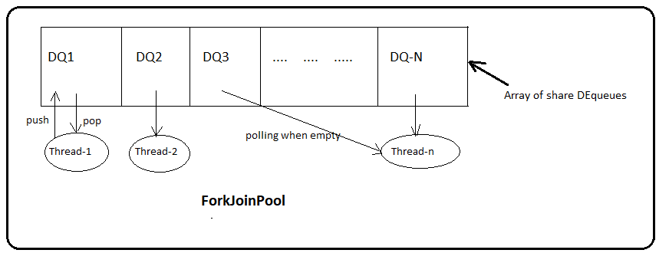
Internals of ForkJoinPool
Initially , only a single thread in a ForkJoinPool will be busy when you submit a task. The thread will begin to subdivide the larger task into smaller tasks. Each time a task is divided into two or more tasks, we fork the every new subtask except the last one we compute. After the computation we invoke join to wait for the forked tasks to complete. This divide-and-conquer process continues untill all the tasks are executed, and all the queues become empty. Mote generally this work stealing algorithm is used to redistribute and balance the tasks among the worker threads in the pool. Below figure shows how this process occurs.
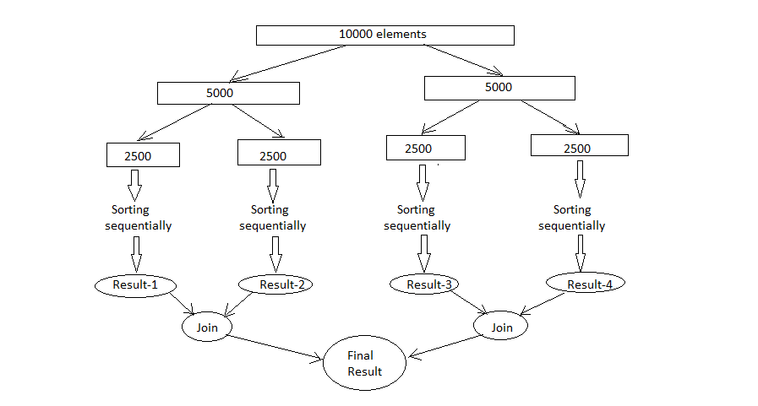
Splitting of tasks

Fork and Join Explained
Before we look at the ForkJoinPool I want to explain how the fork and join principle works in general.
The fork and join principle consists of two steps which are performed recursively. These two steps are the fork step and the join step.

Fork
A task that uses the fork and join principle can fork (split) itself into smaller subtasks which can be executed concurrently. This is illustrated in the diagram below:
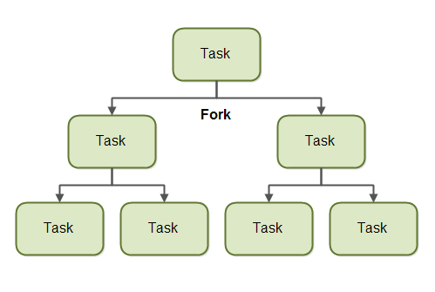
By splitting itself up into subtasks, each subtask can be executed in parallel by different CPUs, or different threads on the same CPU.
A task only splits itself up into subtasks if the work the task was given is large enough for this to make sense. There is an overhead to splitting up a task into subtasks, so for small amounts of work this overhead may be greater than the speedup achieved by executing subtasks concurrently.
The limit for when it makes sense to fork a task into subtasks is also called a threshold. It is up to each task to decide on a sensible threshold. It depends very much on the kind of work being done.

Join
When a task has split itself up into subtasks, the task waits until its subtasks have finished executing.
Once its subtasks have finished executing, the task may join (merge) all the results into one result. This is illustrated in the diagram below:

Of course, not all types of tasks may return a result. If the tasks do not return a result then a task just waits for its subtasks to complete. No result merging takes place then.

The Java ForkJoinPool
The Java ForkJoinPool is a special thread pool which is designed to work well with fork-and-join task splitting. The ForkJoinPool class is located in the java.util.concurrent package, so the full class name is java.util.concurrent.ForkJoinPool.

Creating a ForkJoinPool
You can create a Java ForkJoinPool in 2 ways. Either via the ForkJoinPool constructor, or via a static factory method in the ForkJoinPool class.
Let's first see how to create a Java ForkJoinPool using its constructor. As a parameter to the ForkJoinPool constructor you pass the indicated level of parallelism you desire. The parallelism level indicates how many threads or CPUs you want to work concurrently on tasks passed to the ForkJoinPool. Here is a Java ForkJoinPool creation example:
ForkJoinPool forkJoinPool = new ForkJoinPool(4);
This example creates a ForkJoinPool with a parallelism level of 4.
You can also use the static factory method ForkJoinPool.commonPool(). This returns the shared ForkJoinPool instance. This common ForkJoinPool will have a parallelism level defined internally (according to the workload submitted to it - as far as I understand).
If you need to use ForkJoinPool instances in several places in your application, it might be a better idea to just use the shared common ForkJoinPool, rather than creating your own. That way you might share the underlying hardware better, than if you create multiple ForkJoinPool instances yourself and try to match their parallelism to the underlying hardware yourself.
Here is how you create a Java ForkJoinPool using the static factory method commonPool():
ForkJoinPool forkJoinPool = ForkJoinPool.commonPool();

Submitting Tasks to the ForkJoinPool
You submit tasks to a ForkJoinPool similarly to how you submit tasks to an ExecutorService. You can submit two types of tasks. A task that does not return any result (an "action"), and a task which does return a result (a "task"). These two types of tasks are represented by the RecursiveAction and RecursiveTask classes. How to use both of these tasks and how to submit them will be covered in the following sections.
Both the RecursiveAction and the RecursiveTask classes are subclasses of the ForkJoinTask class, by the way.

RecursiveAction
A RecursiveAction is a task which does not return any value. It just does some work, e.g. writing data to disk, and then exits.
A RecursiveAction may still need to break up its work into smaller chunks which can be executed by independent threads or CPUs.
You implement a RecursiveAction by subclassing it. Here is a RecursiveAction example:
import java.util.concurrent.RecursiveAction;

public class MyRecursiveAction extends RecursiveAction {

private long workLoad = 0;

public MyRecursiveAction(long workLoad) {
this.workLoad = workLoad;
}

@Override
protected void compute() {
//if work is above threshold, break tasks up into smaller tasks
if(this.workLoad > 16) {
System.out.println("Splitting workLoad : " + this.workLoad);

long workload1 = this.workLoad / 2;
long workload2 = this.workLoad - workload1;

MyRecursiveAction subtask1 = new MyRecursiveAction(workload1);
MyRecursiveAction subtask2 = new MyRecursiveAction(workload2);

subtask1.fork();
subtask2.fork();

} else {
System.out.println("Doing workLoad myself: " + this.workLoad);
}
}
}
This example is very simplified. The MyRecursiveAction simply takes a fictive workLoad as parameter to its constructor. If the workLoad is above a certain threshold, the work is split into subtasks which are also scheduled for execution (via the .fork() method of the subtasks. If the workLoad is below a certain threshold then the work is carried out by the MyRecursiveAction itself.
You can schedule a MyRecursiveAction for execution with a Java ForkJoinPool like this:
MyRecursiveAction myRecursiveAction = new MyRecursiveAction(24);

forkJoinPool.invoke(myRecursiveAction);

RecursiveTask
A RecursiveTask is a task that returns a result. It may split its work up into smaller tasks, and merge the result of these smaller tasks into a collective result. The splitting and merging may take place on several levels. Here is a RecursiveTask example:
import java.util.concurrent.RecursiveTask;

public class MyRecursiveTask extends RecursiveTask<Long> {

private long workLoad = 0;

public MyRecursiveTask(long workLoad) {
this.workLoad = workLoad;
}

protected Long compute() {

//if work is above threshold, break tasks up into smaller tasks
if(this.workLoad > 16) {
System.out.println("Splitting workLoad : " + this.workLoad);

long workload1 = this.workLoad / 2;
long workload2 = this.workLoad - workload1;

MyRecursiveTask subtask1 = new MyRecursiveTask(workload1);
MyRecursiveTask subtask2 = new MyRecursiveTask(workload2);

subtask1.fork();
subtask2.fork();

long result = 0;
result += subtask1.join();
result += subtask2.join();
return result;

} else {
System.out.println("Doing workLoad myself: " + this.workLoad);
return workLoad * 3;
}
}
}
This example is similar to the RecursiveAction example except it returns a result. The class MyRecursiveTask extends RecursiveTask<Long> which means that the result returned from the task is a Long .
The MyRecursiveTask example also breaks the work down into subtasks, and schedules these subtasks for execution using their fork() method.
Additionally, this example then receives the result returned by each subtask by calling the join() method of each subtask. The subtask results are merged into a bigger result which is then returned. This kind of joining / mergining of subtask results may occur recursively for several levels of recursion.
You can schedule a RecursiveTask like this:
MyRecursiveTask myRecursiveTask = new MyRecursiveTask(128);

long mergedResult = forkJoinPool.invoke(myRecursiveTask);

System.out.println("mergedResult = " + mergedResult);
Notice how you get the final result out from the ForkJoinPool.invoke() method call.

How to use ForkJoinPool in Java

Use ForkJoinPool to break down computationally intensive tasks and execute them in parallel for better Java application performance.
ForkJoinPool is a powerful Java class used for processing computationally intensive tasks. It works by breaking down tasks into smaller subtasks and then executing them in parallel. This thread pool operates using a divide-and-conquer strategy, which enables it to execute tasks concurrently, increasing throughput and reducing processing time.
One of the unique features of ForkJoinPool is the work-stealing algorithm it uses to optimize performance. When a worker thread finishes its assigned tasks, it will steal tasks from other threads, ensuring that all threads are working efficiently, and no computer resources are wasted.
ForkJoinPool is used extensively in Java’s parallel streams and CompletableFutures, allowing developers to execute tasks concurrently with ease. Additionally, other JVM languages like Kotlin and Akka use this framework to build message-driven applications that require high concurrency and resilience.

Thread pooling with ForkJoinPool
The ForkJoinPool class stores workers, which are processes being run on each CPU core from the machine. Each of those processes is stored in a deque, which stands for double-ended queue. As soon as a worker thread runs out of tasks, it begins stealing tasks from other workers.
First, there will be the process of forking the task; this means that a big task will be broken down into smaller tasks that can be executed in parallel. Once all subtasks are completed, they are rejoined. The ForkJoinPool class then provides one result, as shown in Figure 1.
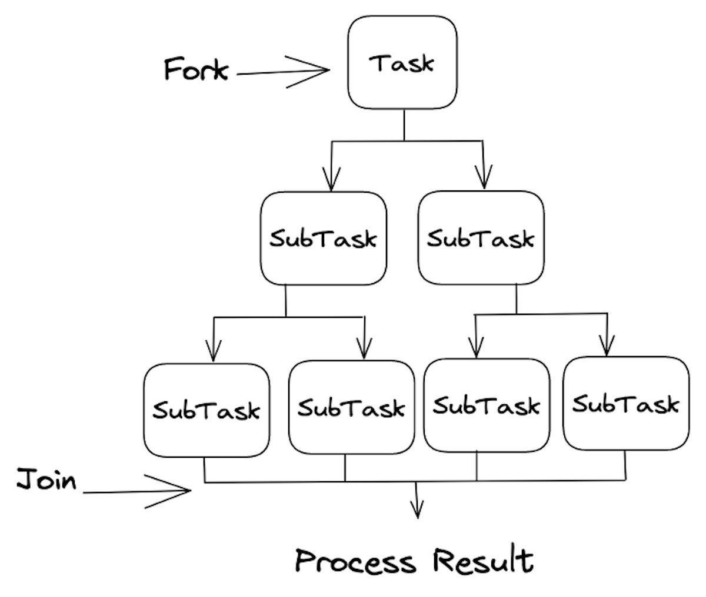IDG
FIGURE 1. FORKJOINPOOL IN ACTION
When the task is submitted in a ForkJoinPool, the process will be divided into smaller processes and pushed to a shared queue.
Once the fork() method is invoked, tasks are invoked in parallel until the base condition is true. Once processing is forked, the join() method ensures that threads wait for each other until the process has been finalized.
All the tasks initially will be submitted to a main queue, and this main queue will push tasks to the worker threads. Notice that tasks are inserted using the LIFO (last-in, first-out) strategy which is the same as the stack data structure.
Another important point is that the ForkJoinPool uses deques to store tasks. This gives the ability to use either LIFO or FIFO (first-in, first-out), which is necessary for the work-stealing algorithm.
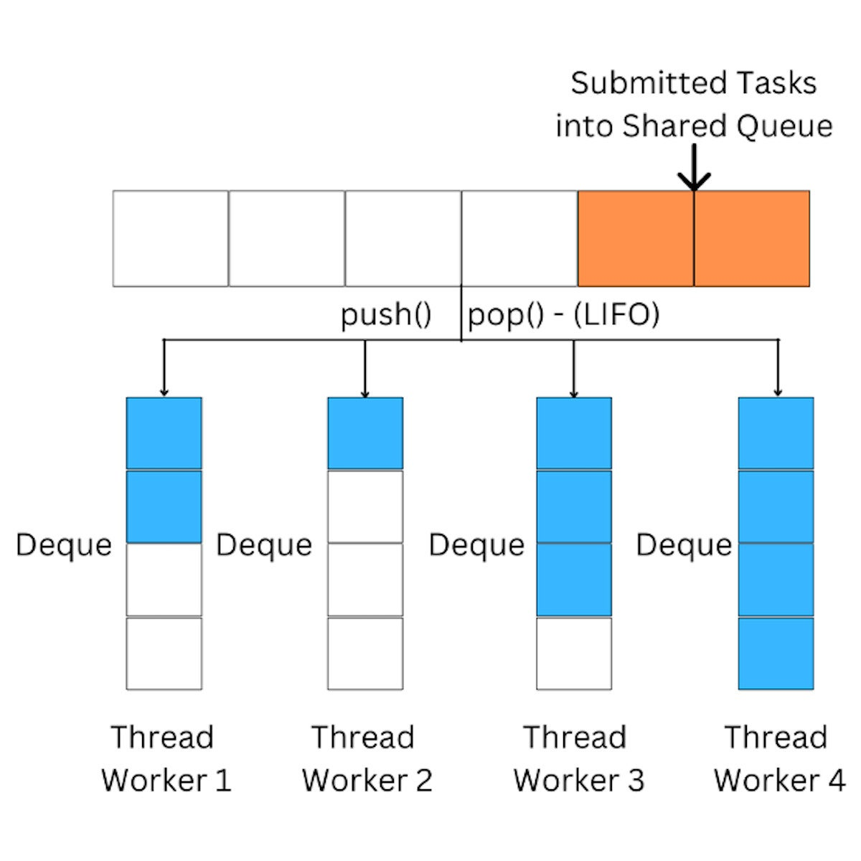IDG
FIGURE 2. FORKJOINPOOL USES DEQUES TO STORE TASKS

The work-stealing algorithm
Work-stealing in ForkJoinPool is an effective algorithm that enables efficient use of computer resources by balancing the workload across all available threads in the pool.
When a thread becomes idle, instead of remaining inactive, it will attempt to steal tasks from other threads that are still busy with their assigned work. This process maximizes the utilization of computing resources and ensures that no thread is overburdened while others remain idle.
The key concept behind the work-stealing algorithm is that each thread has its own deque of tasks, which it executes in a LIFO order.
When a thread finishes its own tasks and becomes idle, it will attempt to “steal” tasks from the end of another thread’s deque, following a FIFO strategy, the same as the queue data structure. This allows the idle thread to pick up the tasks that have waited for the longest time, reducing the overall waiting time and increasing throughput.
In the following diagram, Thread 2 steals a task from Thread 1 by polling the last element from Thread 1’s deque, and then executes the task. The stolen task is typically the oldest one in the deque, which ensures that the workload is evenly distributed among all threads in the pool.
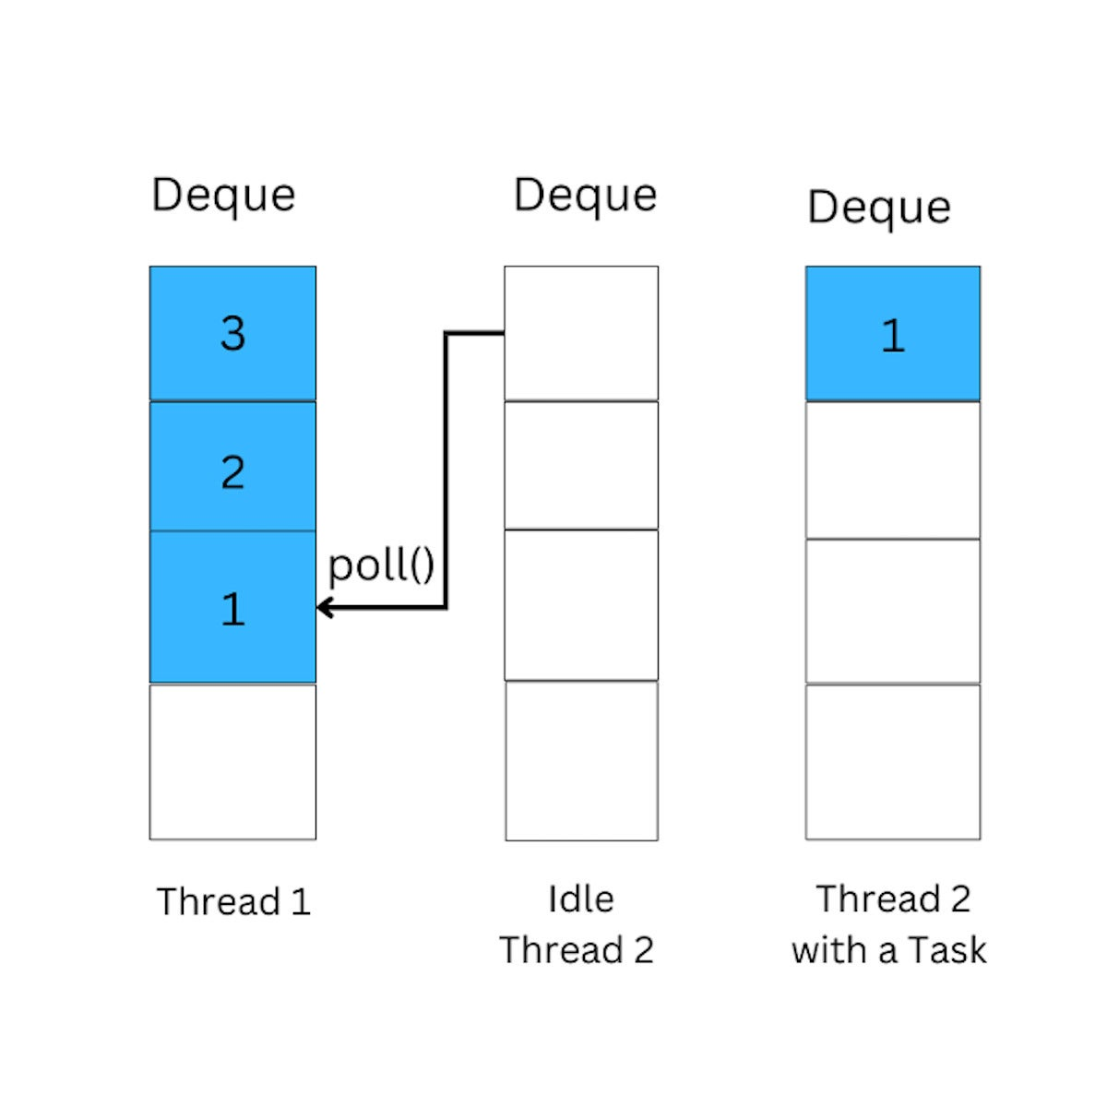IDG
FIGURE 3. AN ILLUSTRATION OF FORKJOINPOOL’S WORK-STEALING ALGORITHM
Overall, ForkJoinPool‘s work-stealing algorithm is a powerful feature that can significantly improve the performance of parallel applications by ensuring that all available computing resources are utilized efficiently.

ForkJoinPool’s main classes
Let’s take a quick look at the main classes that support processing using ForkJoinPool.
- ForkJoinPool: Creates a thread pool to use the ForkJoin framework. It works similarly to other thread pools. The most important method from this class is commonPool(), which creates the ForkJoin thread pool.
- RecursiveAction: The main function of this class is to compute recursive actions. Remember that in the compute() method, we don’t return a value. This is because the recursion happens within the compute() method.
- RecursiveTask: This class works similarly to the RecursiveAction, with the difference that the compute() method will return a value.

Using RecursiveAction
To use the RecursiveAction capabilities we need to inherit it and override the compute() method. Then, we create the subtasks with the logic that we want to implement.
In the following code example, we’ll calculate the number that is double each number in the array in parallel and recursively. We are limited to calculate two by two array elements in parallel.
As you can see, the fork() method invokes the compute() method. As soon as the whole array has the sum from each of its elements, the recursive invocations stops. Once all the elements of the array are summed recursively, we show the result.

Listing 1. An example of RecursiveAction

import java.util.concurrent.ForkJoinPool;
import java.util.concurrent.RecursiveAction;

public class ForkJoinDoubleAction {
public static void main(String[] args) {
ForkJoinPool forkJoinPool = new ForkJoinPool();
int[] array = {1, 5, 10, 15, 20, 25, 50};
DoubleNumber doubleNumberTask = new DoubleNumber(array, 0, array.length);

// Invokes compute method
forkJoinPool.invoke(doubleNumberTask);
System.out.println(DoubleNumber.result);
}
}

class DoubleNumber extends RecursiveAction {

final int PROCESS_THRESHOLD = 2;
int[] array;
int startIndex, endIndex;
static int result;

DoubleNumber(int[] array, int startIndex, int endIndex) {
this.array = array;
this.startIndex = startIndex;
this.endIndex = endIndex;
}

@Override
protected void compute() {
if (endIndex - startIndex <= PROCESS_THRESHOLD) {
for (int i = startIndex; i < endIndex; i++) {
result += array[i] * 2;
}
} else {
int mid = (startIndex + endIndex) / 2;
DoubleNumber leftArray = new DoubleNumber(array, startIndex, mid);
DoubleNumber rightArray = new DoubleNumber(array, mid, endIndex);

// Invokes the compute method recursively
leftArray.fork();
rightArray.fork();

// Joins results from recursive invocations
leftArray.join();
rightArray.join();
}
}
}
The output from this calculation is 252.
The important point to remember from RecursiveAction is that it doesn’t return a value. It’s also possible to break down the process by using the divide-and-conquer strategy to boost performance.
That’s what we’ve done in Listing 1, instead of calculating the double of each array’s element, we did that in parallel by breaking the array into parts.
It is also important to note that RecursiveAction is most effective when used for tasks that can be efficiently broken down into smaller subproblems.
Therefore, RecursiveAction and ForkJoinPool should be used for computationally intensive tasks where the parallelization of work can lead to significant performance improvements. Otherwise, the performance will be even worse due to the creation and management of threads.

RecursiveTask
In this next example, let’s explore a simple program that breaks in the middle recursively until it reaches to the base condition. In this case, we are using the RecursiveTask class.
The difference between RecursiveAction and RecursiveTask is that with RecursiveTask, we can return a value in the compute() method.

Listing 2. An example of RecursiveTask

import java.util.List;
import java.util.concurrent.ForkJoinPool;
import java.util.concurrent.RecursiveTask;

public class ForkJoinSumArrayTask extends RecursiveTask<Integer> {

private final List<Integer> numbers;

public ForkJoinSumArrayTask(List<Integer> numbers) {
this.numbers = numbers;
}

@Override
protected Integer compute() {
if (numbers.size() <= 2) {
return numbers.stream().mapToInt(e -> e).sum();
} else {
int mid = numbers.size() / 2;
List<Integer> list1 = numbers.subList(0, mid);
List<Integer> list2 = numbers.subList(mid, numbers.size());

ForkJoinSumArrayTask task1 = new ForkJoinSumArrayTask(list1);
ForkJoinSumArrayTask task2 = new ForkJoinSumArrayTask(list2);

task1.fork();

return task1.join() + task2.compute();
}
}

public static void main(String[] args) {
ForkJoinPool forkJoinPool = new ForkJoinPool();

List<Integer> numbers = List.of(1, 3, 5, 7, 9);
int output = forkJoinPool.invoke(new ForkJoinSumArrayTask(numbers));

System.out.println(output);
}
}
Here, we recursively break down the array in the middle until it reaches to the base condition.
Once we have the main array broken, we send list1 and list2 to the ForkJoinSumArrayTask, then we fork the task1, which executes the compute() method and the other part of the array in parallel.
Once the recursion process reaches the base condition, the join method is invoked, joining the results.
The output in this case is 25.

When to Use ForkJoinPool
ForkJoinPool shouldn’t be used in every situation. As mentioned, it’s better to use it for highly-intensive concurrent processes. Let’s see specifically what those situations are:
- Recursive tasks: ForkJoinPool is well-suited for executing recursive algorithms such as quicksort, merge sort, or binary search. These algorithms can be broken down into smaller subproblems and executed in parallel, which can result in significant performance improvements.
- Embarrassingly parallel problems: If you have a problem that can be easily divided into independent subtasks, such as image processing or numerical simulations, you can use ForkJoinPool to execute the subtasks in parallel.
- High-concurrency scenarios: In high-concurrency scenarios, such as web servers, data processing pipelines, or other high-performance applications, you can use ForkJoinPool to execute tasks in parallel across multiple threads, which can help to improve performance and throughput.

Summary
In this article, you saw how to use the most important ForkJoinPool functionalities to execute heavy operations in separate CPU cores. Let’s conclude with the key points from this article:
- ForkJoinPool is a thread pool that uses a divide-and-conquer strategy to execute tasks recursively.
- It is used by JVM languages such as Kotlin and Akka to build message-driven applications.
- ForkJoinPool executes tasks in parallel, enabling efficient use of computer resources.
- The work-stealing algorithm optimizes resource utilization by allowing idle threads to steal tasks from busy ones.
- Tasks are stored in a double-ended queue, with the LIFO strategy used for storage and FIFO for stealing.
- The main classes in the ForkJoinPool framework include ForkJoinPool, RecursiveAction, and RecursiveTask:
  - RecursiveAction is used to compute recursive actions and doesn’t return any values.
  - RecursiveTask is similar but returns a value.
  - The compute() method is overridden in both classes to implement custom logic.
  - The fork() method invokes the compute() method and breaks down the task into smaller subtasks.
  - The join() method waits for subtasks to complete and merges their results.
  - ForkJoinPool is commonly used with parallel streams and CompletableFuture.

